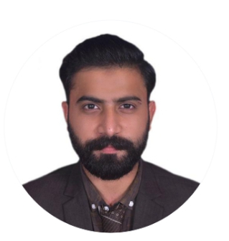

MUHAMMAD AMMAR

**I want to work in the technical and creative environment , where I can polish my skills and use them for platform betterment.**



kalwarammar691@gmail.com



03145831828 - 03065323575



Shamim Masjid, Block 8 Clifton, Karachi, Karachi City, Sindh 75500



01/03/1998



<https://www.linkedin.com/>

in/muhammad-ammar-370622208

<https://www.facebook.com/>

kalwarammar279



ammarabdulqayoom279

**EDUCATION**

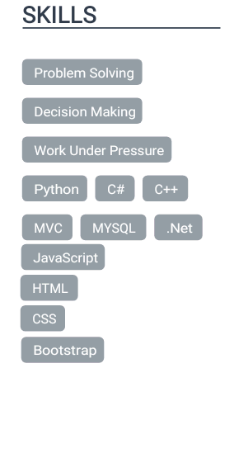

BS in COMPUTER SCIENCE

IQRA UNIVERSITY MAIN CAMPUS, KARACHI

***01/2017-2021.***

**Courses:**

Web Programming Language Object Programing Language

Visual Programing Language Software Project Management

Data Structure Software Project Management

Web Development Design & Analysis of Algorithms

Artiﬁcial intelligence Machine Learning

WORK EXPERIENCE

Tutor and Trainer for IT Department.

*(One year)* ***Karachi, Pakistan***

ORGANIZATIONS

Aamir Institute of Management I.T. Ghotki.

Trainee for Operating System DOS WINDOWS, Office Automation, Programming Concept Using C language,

Network Essentials / MS WINDOWS 2000, Web Development, Objected Oriented Concept Using C++, System

Analysis and Design,

E-Commerce (with ASP), Java Programming, Visual Basic, Project

CERTIFICATES

One Year Diploma in Information Technology (2017)

*From Aamir Institute of Management I.T. Ghotki*.

4 Months training program in the course of C.I.T (2016)

*From Aamir Institute of Management I.T. Ghotki.*

2 months learning with earning program (instant skills)

*Online program*

**LANGUAGES**

English

*Full Professional Proﬁciency*

Urdu

*Full Professional Proﬁciency*

Sindhi

*Full Professional Proﬁciency*

INTERESTS

Cricket

Hocky

Cricket

PERSONAL PROJECTS

Our Food Guru Mobile App and web application developed (1/2020 -12/2020)

Role: as a front-end developer

*FYP From University*

Bank Management System Application

Role: as a java language programmer front end and backend developer

*Semester project*

Made a Led light circuit (hardware project)

Role: wiring and coding in assembly language

*Semester project*

ACHIEVEMENTS

2 months learning with earning program (YouTube Earning, Fiver Account Ranking, Logo Design etc.)

(

Travelling